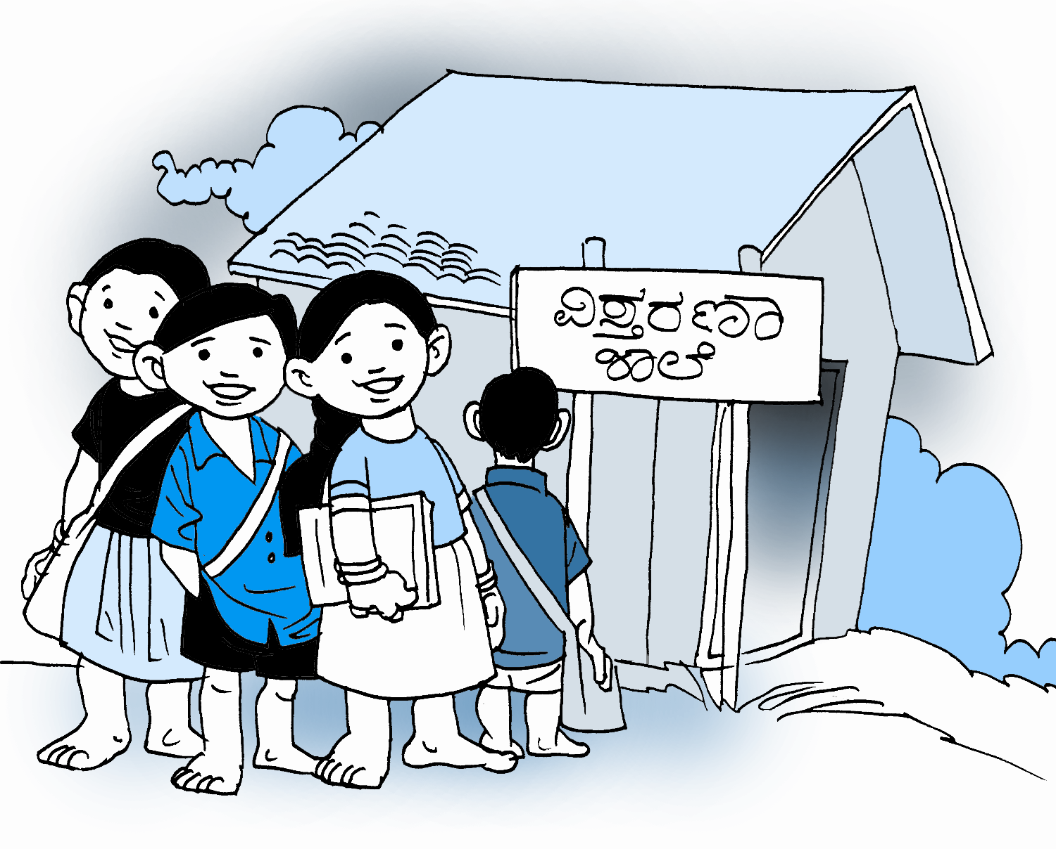

Beyond formal education

By

Damodar Acharya

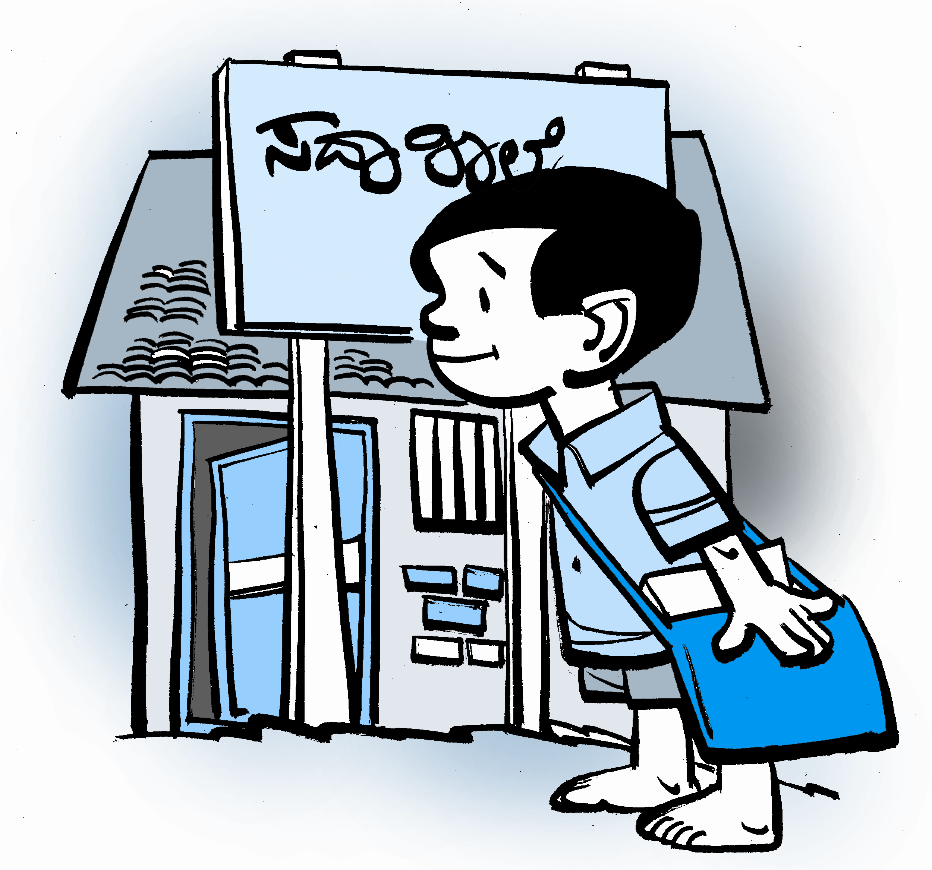

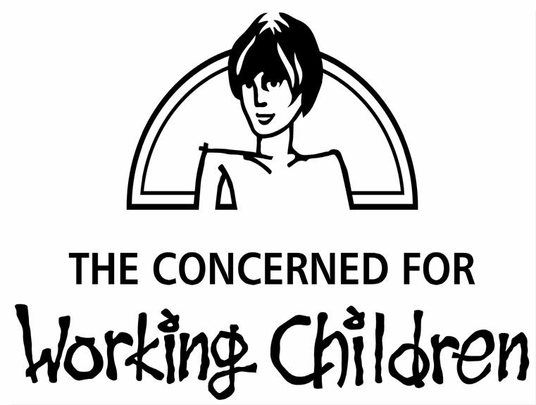

The Concerned for working children
Email: cwc@pobox.com
Website: www.workingchild.org
303/2 L.B.Shastry Nagar
Vimanapura Post
Bangalore 560 017
Ph No:080-25234270/25234272

HE is a farmer with three acres of land and is highly skilled in traditional agriculture. He is about 60 years old. In addition to growing vegetables, fruits, grain, he also has a small dairy and poultry. Having heard his praise, an agricultural officer visited his village and met the farmer. During the conversation, the officer asked, ‘How educated are you?’ The farmer replied, ‘Agriculture is my life.’ The officer retorted, ‘I did not ask about your occupation; I wanted to know what you have studied.’ The farmer responded, ‘I do not know how to write; I only know how to sign.’ ‘You should study’ advised the officer. ‘If you don’t study, nothing is possible. Had you studied, you could have become someone.’

This kind of distinction between the educated and uneducated is a recent one. Now, literacy is being flaunted as the single, one-point mantra a high road to all knowledge and a panacea for all problems in life. The biggest harm this has resulted in is that it both devalues all the knowledge, wisdom and skills that have been passed on from one generation to the other, and considers it second-rate’. There was a time when there was no ‘uneducated’ category. Each person was considered educated and there were hundreds of meaningful ways to ‘get educated’. The canvas of education was vast in its scope and rich in content. Now, one often sees education becoming limited to reading, writing and pressing keyboards to access instant information. Such an understanding of education has also, in myriad ways, increased and reinforced discrimination. That is one reason why, even half a century after we formulated our Constitution, we remain far from realising it in its true spirit.

The prevalent education system does not include ‘education for life’ or ‘education from life’. Hence it fails to respond to the aspirations of people. Take the example of Prema, a child from the fishing community. She found it difficult to learn at school. Every time the teacher addressed her, he would say, ‘you are only fit to break fish heads. Studies will never enter your brain’ Not once did he enquire what difficulties she faced in learning.

Despite the humiliation, Prema did not drop out of school for the simple reason that it allowed her to step out of her home and experience the companionship of her friends. Had she said ‘no’ to school, she would be detained within the home and left with little option but tying up the knots on torn fishing nets as her destiny. But in opting for school, she was unable to link the reading, writing and arithmetic there to her life. The sea that was her lifeblood, her experience as a girl found no place within her school. If she ventured to speak about the fish, about the typhoon, about their life when fish is scarce, the teacher’s response was: ‘you are only fit to break fish heads. Her knowledge and the questions she asked were not considered important. She too was unclear as to what she might do in the future with what she learnt at school. As pressures at school increased, Prema was unable to cope and finally decided to drop out.

She gradually got used to the work assigned to her at home. She walked miles on end to fetch fuel. It was on one such errand that she came in contact with Bhima Sangha. The company of new friends inspired her. Bhima Sangha is the first organisation of working children in Asia. This organisation – gradually and affectionately – enabled working children in Prema’s village to get together. It encouraged them to share their problems and views with each other. It made it possible for them to start ‘extension schools’ to learn.2 It helped them to create forums to interact with the adults of the village. Gently and gradually it created awareness among the adults. Prema was totally involved and brought her customary zeal and energy to these processes.

Children began an exercise to collect detailed information regarding their problems. Prema and her fellow members soon became household names in their village. This information base led to several new experiments. Children set up Makkala Panchayats3 to participate in decision-making in the local government. In Toofan Panchayats,4 task forces5 for the protection of children’s rights were formed. Systems and structures to provide assistance to children in crises were put in place. The teaching methodology in the schools experienced improvement. The entire village – government representatives, school teachers, doctors and members of women’s organisations – began to appreciate and articulate issues from the children’s perspective.

It increasingly became possible in the schools to introduce the concerns of children. New doors opened up and children played a major role in making that possible. Even those adults who viewed working children as ‘good for nothing’ began to recognise how unfair such opinions were – they began to view children with new eyes.

In the entire panchayat, it was recognised that children should be provided an education which is intimately related to their aspirations and lives. In addition, there was an open discussion about discriminatory practices, immorality, gender related abuses– all these found a long overdue place in education.

Just as children learn how to draw the world and the national maps, they also learnt to map their villages – this included social mapping, economic mapping, geographical mapping and environmental resource mapping. The young collected information relating to financial and social indicators and presented their data to the entire panchayat. Those very children, earlier considered dumb, gained tremendous respect within their community. At a public function, Prema’s former teacher spoke of how the school took pride in Prema for her concern and total commitment to all children as president of the Makkala Panchayat.

The Makkala Panchayats played an important role in making available new methods of teaching and learning to all children. They demonstrated how education is not limited to literacy and knowledge of facts, but forms the very basis for the comprehensive development of a child. These youngsters inspired the vision of a new world.

What after all is the purpose of education? If it is to enhance the overall development of an individual, then how do we recognize and value such individuals? It is generally accepted that for comprehensive development of a child, the education process should integrate physical, emotional/psychological and spiritual development. This was done in our traditional educational systems. Each community had its own expression of spirituality Â– one not subsumed by a monoculture Â– which was reflected in its education system. But, those systems did not integrate different castes, classes and genders. The different streams of education meant for different groups of people remained exclusive within the framework, content and methods developed for them. The child from a Brahmin family and one from a tribal community had access to different education systems, but the tragedy of those systems was that they contributed to further discrimination based on vocation, caste and gender.

In order to rectify those problems in the traditional education systems, our country came up with the compulsory education programme. Unfortunately this in turn has only created new problems.

Manju is a child from a tribal community. This active and enthusiastic boy knew how to climb trees, swim, sing and dance by the time he was ten years old. He could narrate stories and describe his experiences in a very captivating manner. He was the first child in his family to attend a school that taught reading and writing. With great curiosity and excitement, Manju tried to learn at school. He struggled hard to get accustomed to the environment at school that was so very different from home. He coped with this for about four years. As was the practice in his community, Manju had long hair that was tied up in a knot. This became the butt of many jokes at school. His school mates made fun of his dialect, his gestures and his hair. The teacher too referred contemptuously to his long hair. His tree climbing, his songs, his culture – nothing was spared. This persistent devaluation of his language, culture and conduct created an environment that Manju simply could not deal with and his desire to study at the school died out. He left school.

Our new education system has failed to create an environment which addresses the problems of the earlier systems. Instead, it has generated an environment where the individual personality is adversely affected. The indicators to assess this education are not formulated keeping in mind all our children and their life-cultures.

The Bhima Sangha, with children like Prema and Manju as members, raised many such issues. They were able to convince the community that there was an urgent need for an education system that provided an enabling and nurturing environment for the physical, emotional and spiritual growth of all children. It was in this context that we began our exploration into creating a new learning environment that embodied the vision of children.

We were convinced that education cannot and should not take place only within the four walls of a classroom. We identified the need to take aspects of culture, environment, geography, society and politics into consideration while assessing the appropriateness of the education programme. We had repeatedly observed that it was the western perspective or the perspective of the upper castes which defined the parameters of good education’. The Appropriate Education Programme (AEP6) initiated in Namma Bhoomi explored the possibility of defining good education in partnership with children and members of the community.

We believe that while education prepares children for their lives as adults, it should simultaneously enable them to effectively address the issues they confront even as children and adolescents. It should also equip children with knowledge and skills to question and challenge such traditional practices that are unjust and discriminatory. It should make it possible for them to understand their own lives and their world and acquire the freedom to define their own lives. Education should give them a strong grounding in their own communities and then provide them the path to go right up to the international levels if they so desire.

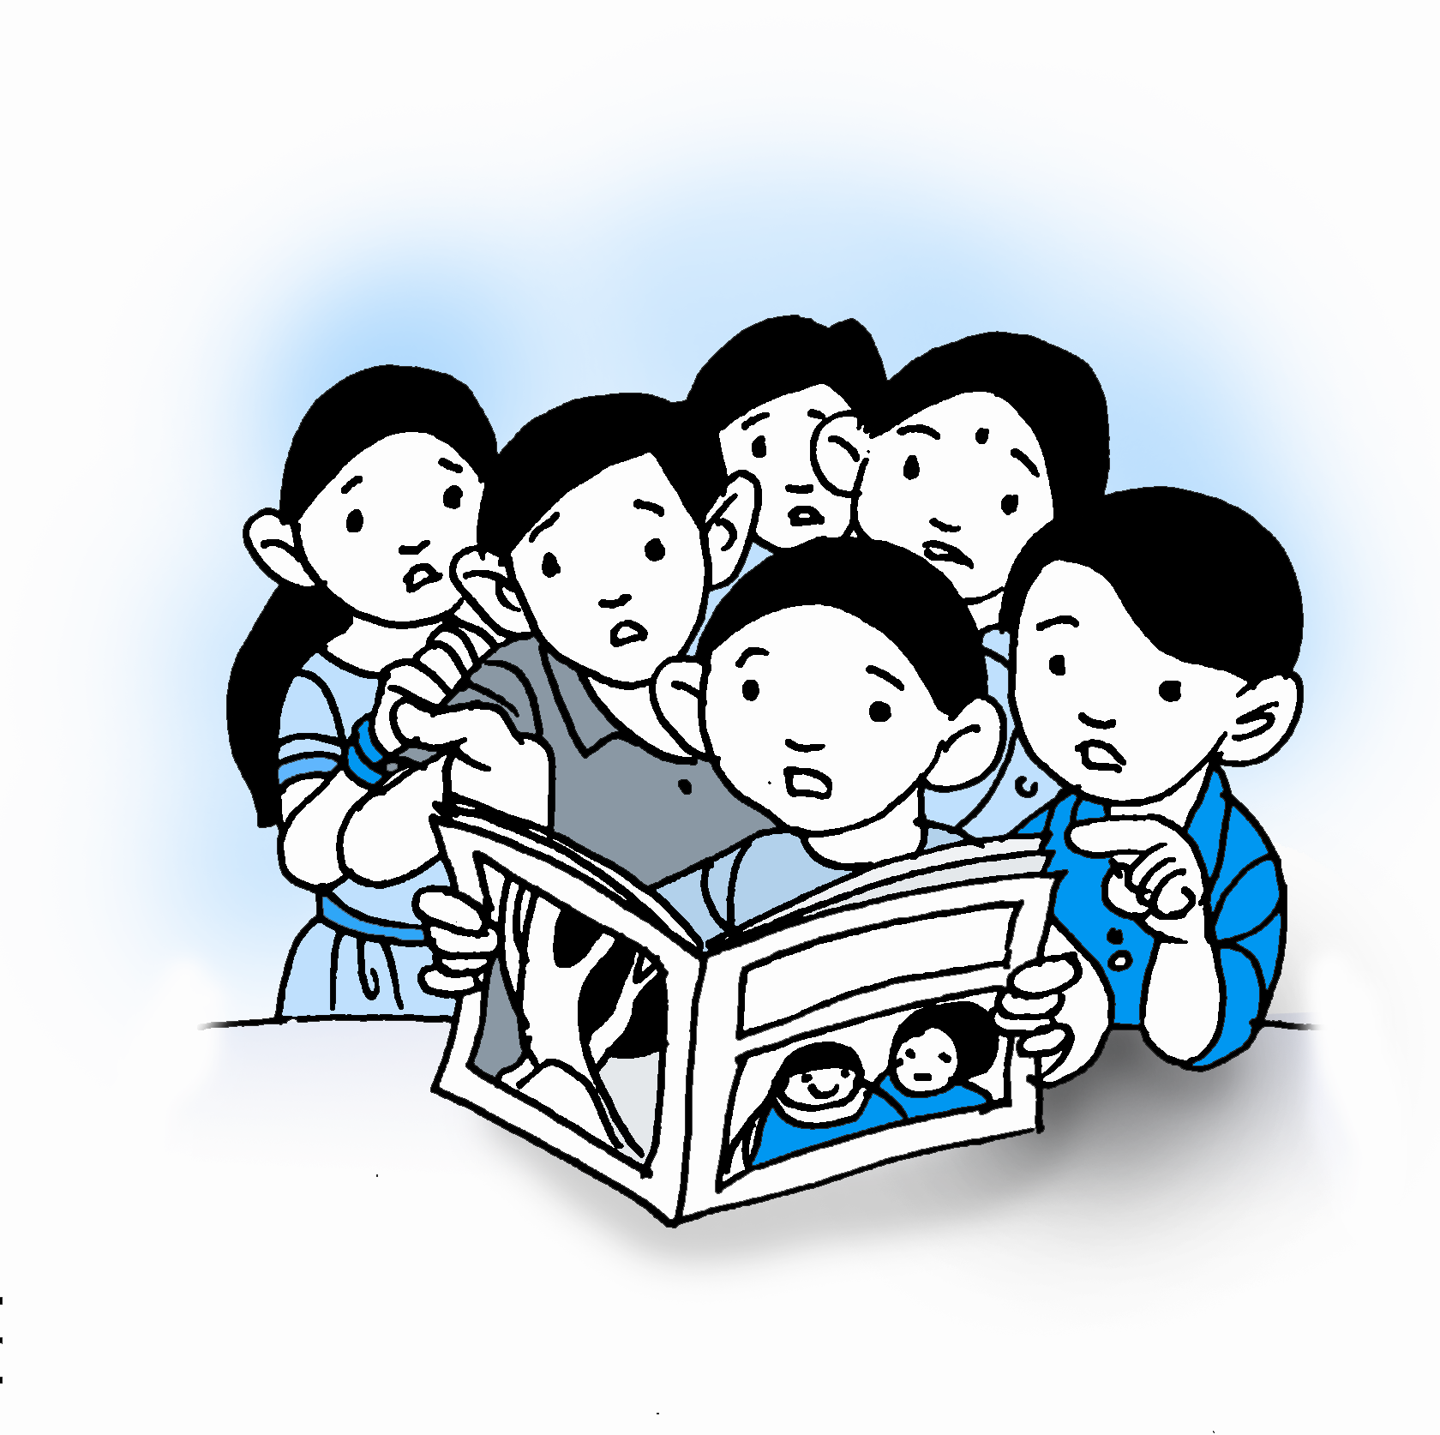
Namma Bhoomi began to take shape to create an environment that was not constrained by caste, class or gender discrimination. Children, members of the community, CWC (The Concerned for Working Children) and individuals with expertise in the field of education collectively examined several systems of education in order to identify positive elements from each of them. The curriculum of the formal education system, inputs related to professional training, management, development and empowerment related issues collectively formed the syllabus. CWCs’ Appropriate Education Programme covers not only the formal syllabus, but the development syllabus, the empowerment syllabus, and the professional (vocational) syllabus.8

In Namma Bhoomi, children are exposed to theory and practical, traditional as well as modern practises. For example, master masons and civil engineers teach the appropriate construction technology. Methodologies to facilitate self-learning were developed over the years. Children formed their own Makkala Panchayats (childrenÂ’s councils) in order to take active part in governing Namma Bhoomi and to gain practical experience in democratic governance and management. This enabled them to learn through listening, seeing and experiencing.

Spirituality is ingrained in our society. For some, spirituality manifests as God and religion; for some as life-beliefs, traditional practices and discipline and for others as sacrifice, ideals, a life led according to their principles. Our cultural heritage draws on all these. They also influence each other. Hence, they teach us tolerance. The education system at Namma Bhoomi captures this richness and enables children to comprehend different forms of spirituality and relate to a wide range of cultural experiences and art forms such as Yakshagana, films, music and theatre. Children not only celebrate different festivals they also understand the history of those festivals and their practices. This makes it possible for them to experience the different strands of our vibrant cultural and social fabric.

Hundreds of children like Prema and Manju who have taken part in the education at Namma Bhoomi, have returned to their communities as ambassadors of all the values and principles they believe in, gain economic stability and social recognition. They have strengthened their youth organisation and are actively shaping the politics and social practices of their communities.

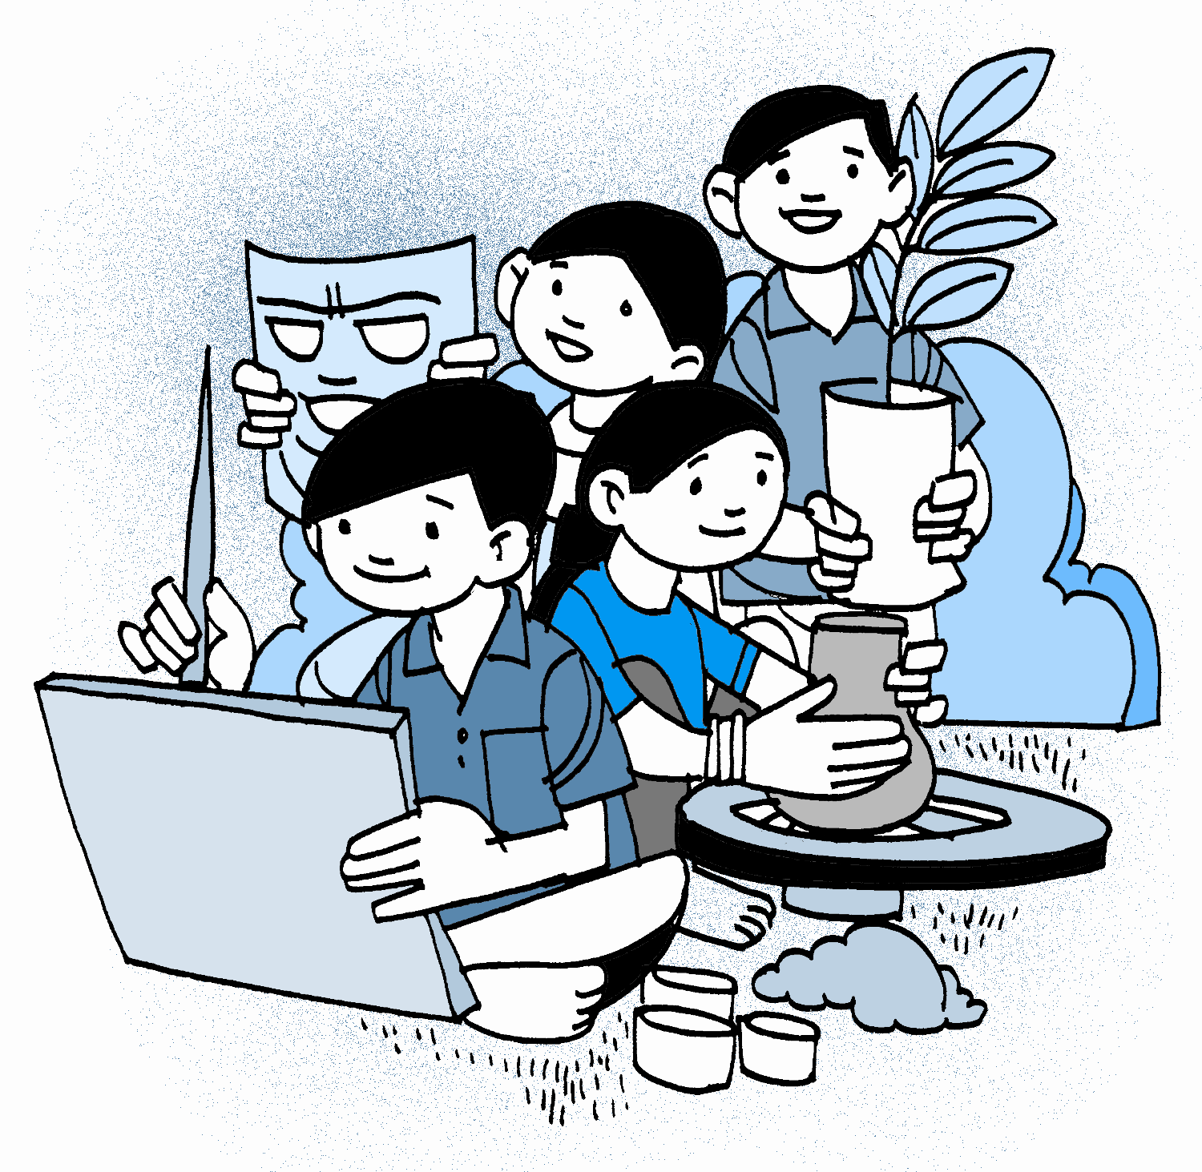
What is most significant about the education at Namma Bhoomi is that its impact is felt strongly in the communities and villages the children come from helping transform other children through the graduates of Namma Bhoomi. The ‘empowerment and the development curriculum’ that evolved as a part of our AEP process is rapidly making inroads into the formal government schools in all 56 panchayats of Kundapur taluk. In these panchayats, children have not only led the process of developing the five year plans, they actively negotiate with local governments to ensure that their rights are realised. They are also initiating the formation of Makkala Panchayats.

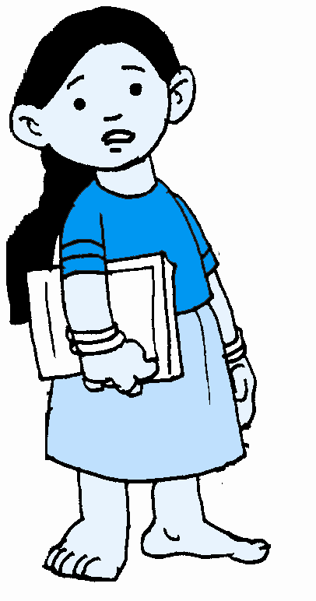
The children we are associated with have taken up the issues of child marriage, child labour, migrant families, female foeticide, HIV Â– and are pro-actively addressing them at several levels. They serve as resource persons in capacity building programmes for elected members of the panchayats, police, government officials and other NGOs. They have formed their own organisations and advocate issues that concern them at various local, national and international forums. It is their political, social and cultural participation that has empowered them to realise their self-worth, giving a new meaning to education.

All this became possible by building on an important principle in earlier (traditional) education systems. The education of each community served to enhance the ability of its members to realise their aspirations a principle that is still relevant for every country and every community. If the education system of our country does not enable children to realise their aspirations, it will retard the progress of the nation.

The dominant (formal) education system in our country has been imported and is far from fulfilling our aspirations for creating a truly participatory democracy. We are a democracy, so our education should also be democratic and for democracy. Democratic education does not only mouth democracy; it is one in which the learning environment, relationships, decisions and practices are democratic.

Creating such a system was a major challenge and only our partnership with children showed us the way to meet it. Children, their organisations, their councils and the empowerment education materials that were developed embodied democracy. We, adults and children, together had to learn how to practice what we preached. This understanding deepened over time and became a dynamic joint learning experience that continues to teach us new lessons.

Each individual should be enabled to realise his/her optimum potential. Friendship, cooperation, tolerance, respect and equality should become our guiding lights. Only when education makes it possible for the integrated strengths of an individual to blossom within a democratic frame, will personal growth, societal progress and global well-being become a reality.

Footnotes:

1. A union of, by and for working children in Karnataka facilitated by the Concerned for Working Children, with a membership of several thousand children, striving for the realisation of children’s rights.

2. An extension school is an extension of the formal school, where all children though registered at the formal school, are able to study at their convenience with regard to timings, location and scholastic needs.

3. A children’s village council or parallel government of children, set up jointly by Bhima Sangha and the Concerned for Working Children. It is a forum for all children to participate in decision-making and governance at the panchayat level.

4. Panchayat/Area where CWCÂ’s Toofan programme is implemented. This is a programme of comprehensive development implemented by CWC with primary focus on the empowerment of children. It aims at enabling children to play a proactive role in decision-making and governance. Bhima Sangha, Makkala Panchayat, Namma Sabha and the respective Gram Panchayats are partners in this programme.

5. A tripartite body devised by CWC comprising of children’s representatives, government officials and elected representatives, and community based organisations. This body was set up to link the Makkala Panchayat with the Gram Panchayat and focuses primarily on issues related to children that are raised by the Makkala Panchayat.

6. A comprehensive education programme designed and developed by CWC based on learning material that enables children to learn at their own pace and interest. It covers the formal, rights and developmental syllabus.

7. CWCs Regional Resource Centre situated in Kundapur, where every year close to a hundred children equip themselves with livelihood skills and education.

8. Details regarding the different syllabi are available on request.

