REPORT OF THE
MATTADARA SWABHIMANA HORATA – 2010
THE GP ELECTION CAMPAIGN STRATEGY

BACKGROUND:
We, the members of the Gram Panchayat Hakkottaya Andolana are very distressed with the developments in Karnataka and see that it is following the same pattern as Gujarat. We have been disturbed by the repeated moves to dilute Panchayati Raj in this state and the deliberate delay in announcing the Gram Panchayat elections. The pressure built across the state by our members finally resulted in the announcement of these elections.

On 12th April the Election Commissioner Sri C.R. Chikkamath finally announced the GP election to a press conference. On the 15th April orders were sent to DC’s announcing the election schedule and the code of conduct. It was only on 19th April that Gram Panchayats were notified. However, 152 Gram Panchayats whose term ends in June have not be notified as a part of this election.

When the elections were announced we are afraid that they would go the way of the recent BBMP elections when money flowed and votes were bought. While the BBMP election concerned one city - Bengaluru, the Gram Panchayat elections would decide the fate of 5,628 local Governments. Flush with the success of the BBMP elections, the Chief Minister of Karnataka declared that the BJP would capture all the Gram Panchayats in the State presumably using the same tactics as those used in the BBMP and this would only vitiate an already murky atmosphere.

The feedback we were receiving from the field and our members was that; [1] ‘honest’ candidates were very hesitant to stand for this election as they feared the ‘money power’ that will be unleashed which will take the expenditure from Rs: 5,000/- (the expenditure in the previous election) to Rs: 5,00,000/- or more, a sum that they have no way nor intention of raising or spending; [2] others, who are intent on standing and winning, are seeking an alliance with the BJP as they see that as their only chance; [3] candidates sponsored by the BJP will be backed by ‘contractors’ who have a vested interest in schemes such as NEGRA and Rajiv Gandhi Housing Projects.

Though the Gram Panchayats are not party based, candidates are decided by political parties and election expenses are covered by them. Further, political parties pay for the purchase of votes and payment to intermediaries or vote catchers.

A quick survey of the scene revealed that there are so few who are really committed to ‘clean and good governance’ in Karnataka. The opposition in Karnataka did not seem to have a strategy as they too were preparing to adopt the same ‘rules’ as the BJP to play this game that would only reinforce corruption, money power and devalue the rights and obligations of citizens, reducing us to mere commodities that can be bought!

The youth of our nation are a very large percentage of this electorate and can make a difference. They have enormous energy, but have no cause to fight for. Hopefully, they are not yet cynical, and if they can find the right cause and leadership to relate to, this energy can be channelled to transform the face of Indian politics if it was possible to capture the imagination of the youth, before they got set in the ‘handout’ mode.

We felt that a campaign for a clean election was called for. We saw this as a very critical campaign and committed ourselves to making an impact to save Gram Panchayats from becoming puppet governments in the hands of moneyed vested interests with no backbone and preserve the last vestige of participatory democracy we have. To create an alternative environment we appealed to all democratic individuals, organisations, unions and political parties to join this campaign.

This campaign will not end with the Gram Panchayat elections; it is a long term process, as so much more needs to be done to attain true local self-governance.

RATIONALE:
Widespread Belief
There is a widespread belief that ‘corruption’ is a way of life and we have to submit to this evil in order to survive. Across the board, common citizens, potential candidates, senior politicians and even the new age ‘young educated’ politicians believed that elections cannot be won without money power. To find the few ‘honourable’ individuals who also believed that this evil could be thwarted were so few that we could count them on our fingers.

This belief was exacerbated by the fact that people had lost faith in Political Parties and often had to choose between the bad and the terrible candidates in an election, leaving them no choice except to boycott the elections altogether. Apathy has set in the middle classes distancing themselves from active participation in what they term ‘dirty’ politics.

We were repeatedly told that “there is no way to change this state of affairs” and that the system (democracy) needs to be replaced with something else and that would take another 100 years. This is “a bitter pill that we have to swallow” and there is no other way.

Political Culture
The objective of the present political culture is to disempower people’s power, authority and rights in order to capture power. This is done by reinforcing ‘wrong’ as the ‘right’ norm through a system of rewards. Selling votes is wrong and every one knows this, however, all political parties encourage this practice by rewarding it, paying for it and even bidding for it.

This process commoditises citizens and our votes and converts ‘elected representatives’ into touts for major contractors and/or ‘feudal patriarchs’. Though these are the acts of a minority they succeed in silencing the majority.

Prevalent Practice
The methods used are age old and well tested. Promote competition and commoditization, erasing peoples memory and with it all connections with history, places and other people. This dissipates the sense of community and togetherness giving rise to communalism and factionalism turning person against person.

Added to this the poor and marginalized are dispossessed in order to protect the middle class and the victims and the poor, working children, children, women, the differently abled children and the marginalized.

Our Conviction
Despite the ‘doomsday’ predictions and the dismal scenario we embarked on this campaign with the enduring belief that deep down people know what is right and wrong and given a chance people will choose the right path. We have an abiding faith in the ‘goodness’ of people and wished to struggle for a positive alternative. So we designed the strategy of this campaign to ‘celebrate the honour of the voter’, empower her and re-establish faith in democracy.
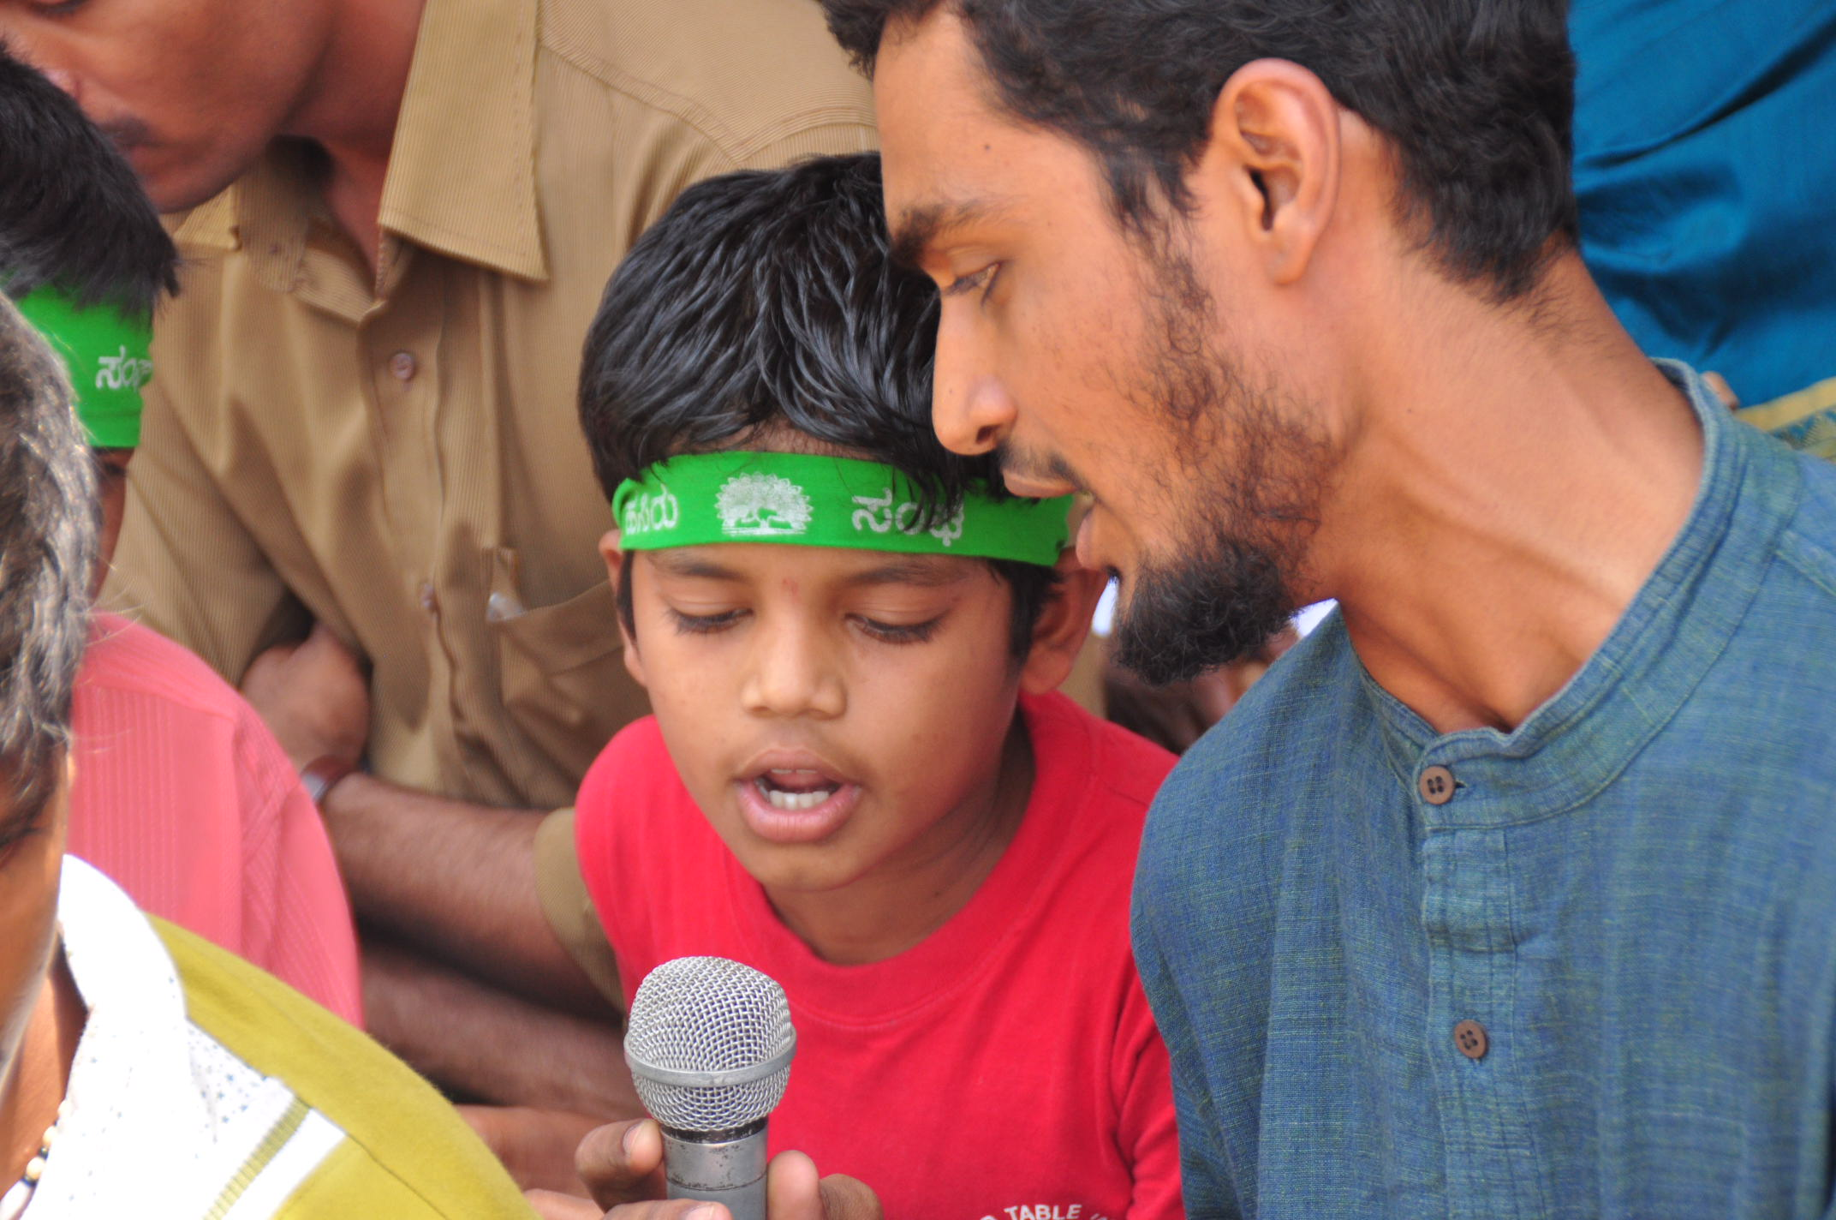
Democracy functions only as well as her citizens use their rights and powers and the extent to which they actively participate to shape it to their desired image. The root of democracy is our vote and the degree to which we use this with introspection and honesty and make informed decisions will determine the quality of the democracy that we have. The cure for an ill functioning democracy is a larger dose of democracy.

STRATEGY:
This campaign State Wide "MY VOTE IS NOT FOR SALE" Campaign was launched at the Belur Panchayat, Somavarpete, Kodagu. Besides educating and empowering voters, this campaign also identified ‘Consensus Candidates’ (selected by voters) who believe in good governance, fulfilled a criteria set by the Andolana and adhered to the Andolana Campaign manifesto.

Below are details of the campaign strategy/agitation/protest that have been chalked out at a meeting of the Gram Panchayat Hakkottaya Andolana on 23rd March 2010 at Kundapura and subsequent discussions among the Convenors and members of the Coordination Committee of the Andolana.

The campaign adhered to the following guidelines:
- The campaign is not linked to any political party or faction.
- All protests shall be non-violent and peaceful.
- There shall be no harm to any individual or damage to property.
- No untoward actions or language shall be used at any time.
- No unnecessary inconvenience shall be caused to the general public.
- All those participating in the campaign shall conduct themselves with utmost decorum and dignity.
- This campaign shall be conducted remembering the spirit and values of Gandhiji, Ram Manohar Lohia, Jayaprakash Narayan, Rajiv Gandhi, Vajpayee, Abdul Nazir Sahib, Ramakrishna Hegde, M. Y. Gorpade and Mani Shanker Aiyer with specific reference to their efforts to further Panchayat Raj.

The Election Campaign Strategy of the Gram Panchayat Hakkottaya Andolana has three main objectives.
- The first objective was to ensure that the constituencies’ select consensus candidates, who stand for good governance, fulfil the criteria set by the Andolana and adhere to the Andolana Campaign manifesto.
- The second objective was to educate and empower voters so that they make informed choices when they cast there vote. It is also to ensure that this election is ‘clean’ and money power is not unleashed in the constituencies to buy votes or induce the youth to campaign for candidates backed by political parties.
- The third objective was to ensure that commensurate action is taken against the State Election Commissioner for dereliction of his constitutionally mandated duty and that he is impeached.

Objective 1:
The campaign for the first objective commenced on the 12th April 2010 in Udupi, Kodagu, Chamraj Nagar and several other Districts and ended with the filing of nominations.

The process is as followings:
- Criteria Setting: Hold Gram Sabha meetings to finalize the criteria for the selection of candidates who should contest and list the values they should subscribe using the criteria set by the Andolana as the basis for the discussions.
- Selection of Candidates: Potential candidates who fulfil the Andolana criteria will be short listed at Ward Sabhas and the candidate will be selected through a vote be the Ward Sabha.
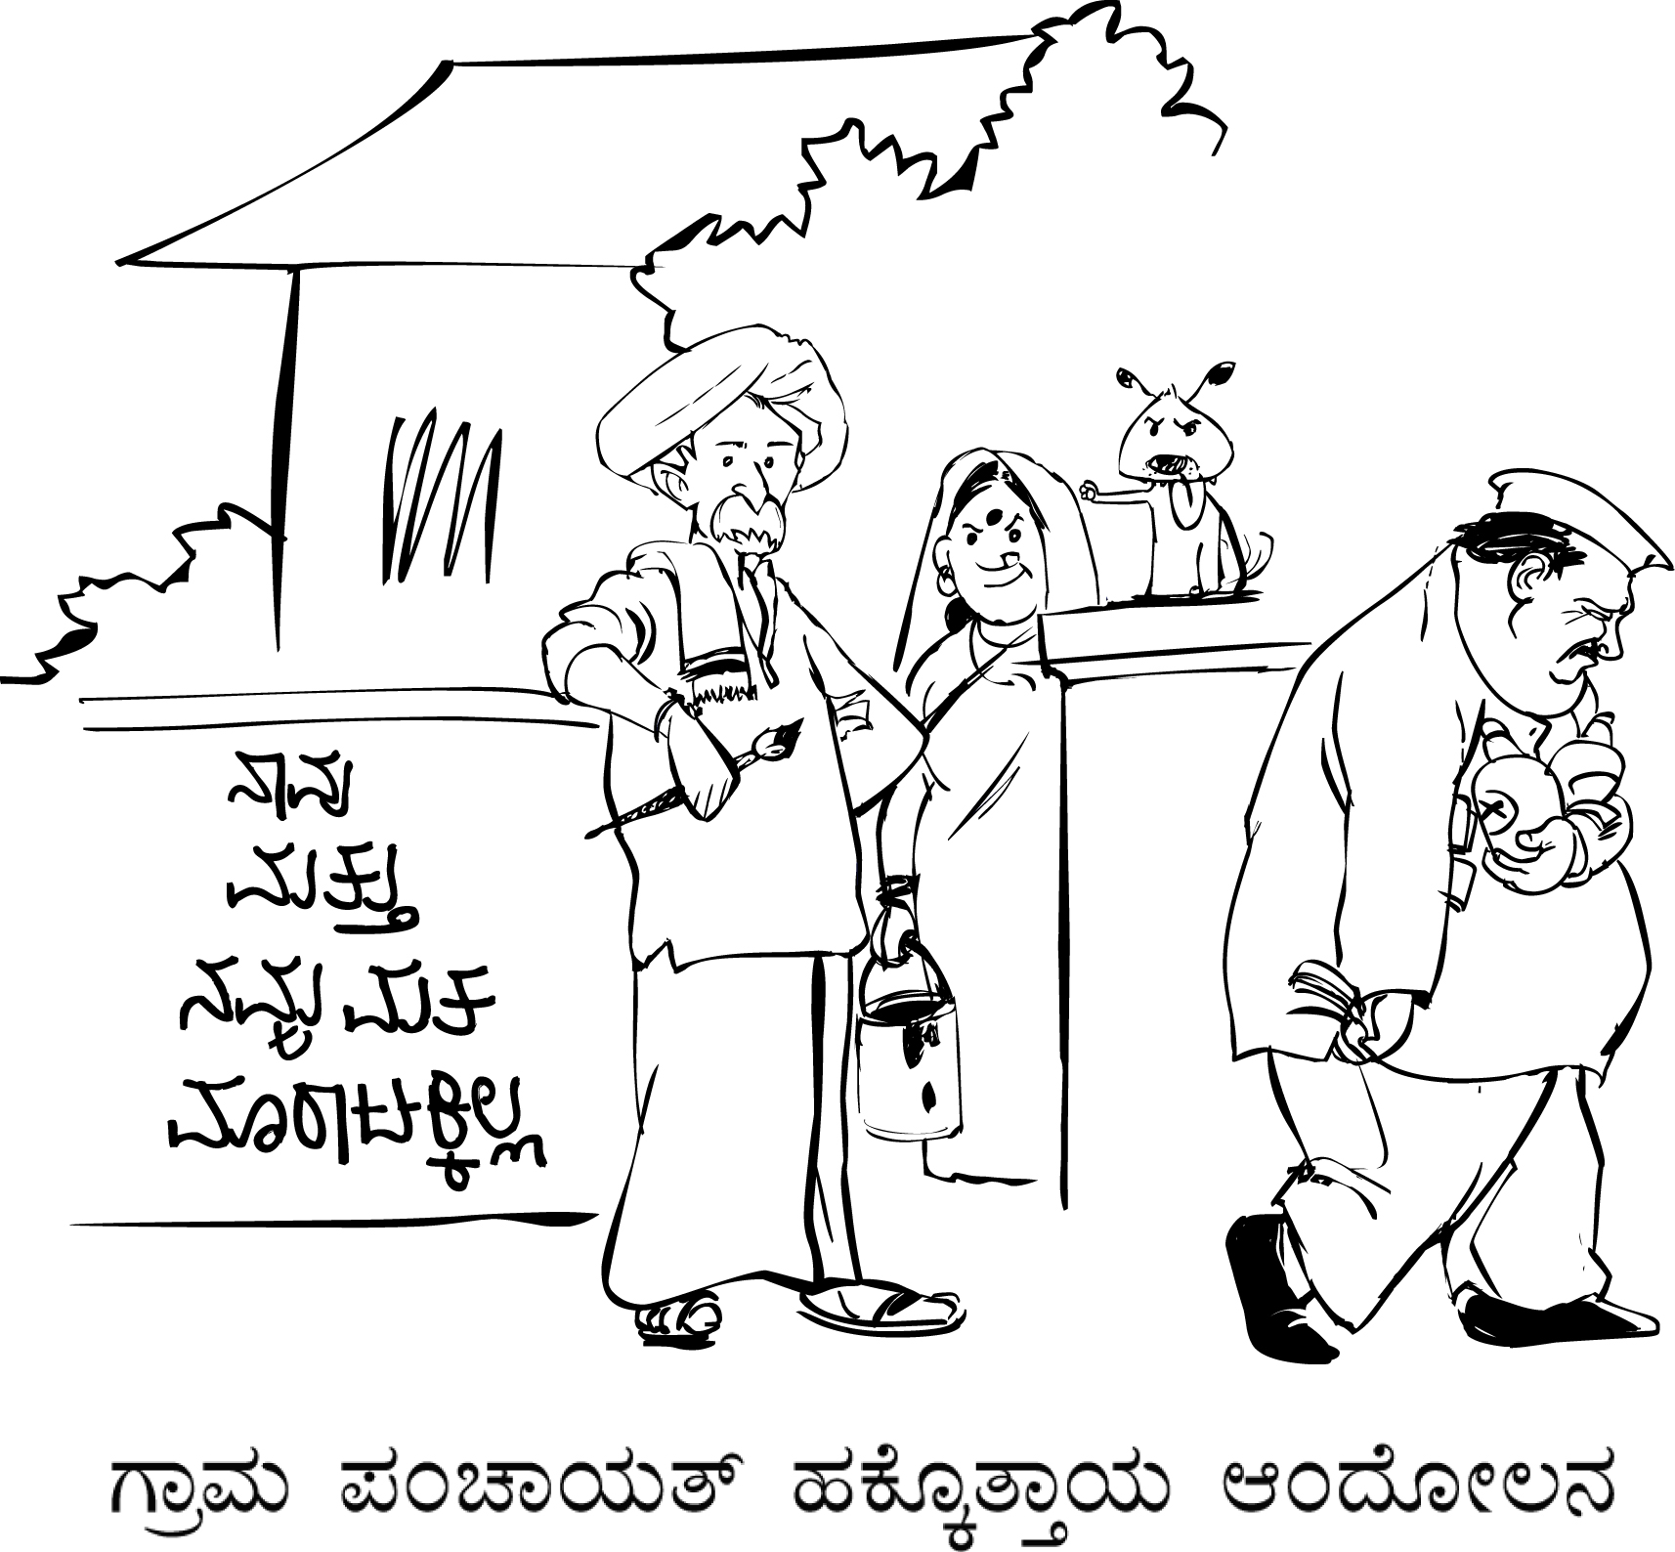
- People’s Manifesto: The Ward Sabhas will also discuss the concerns of the constituents of that ward and this will be the Ward Manifesto. Care should be taken to have discussions with special groups such as migrants, tribal groups, women and especially children and ensure that their concerns are included. All these concerns will also be consolidated as the Manifesto for the Taluk/District.
- Candidates Oath: The Selected Candidates will take an oath to abide by the People’s Manifesto.
- Clean Campaign: The Candidates so selected shall not spend more than the amount stipulated by the code of conduct and shall not submit to the monetary or other pressures of any political party.

Objective 2:
- Educate and Empower Voters: to educate and empower voters so that they make informed choices when they cast there vote.
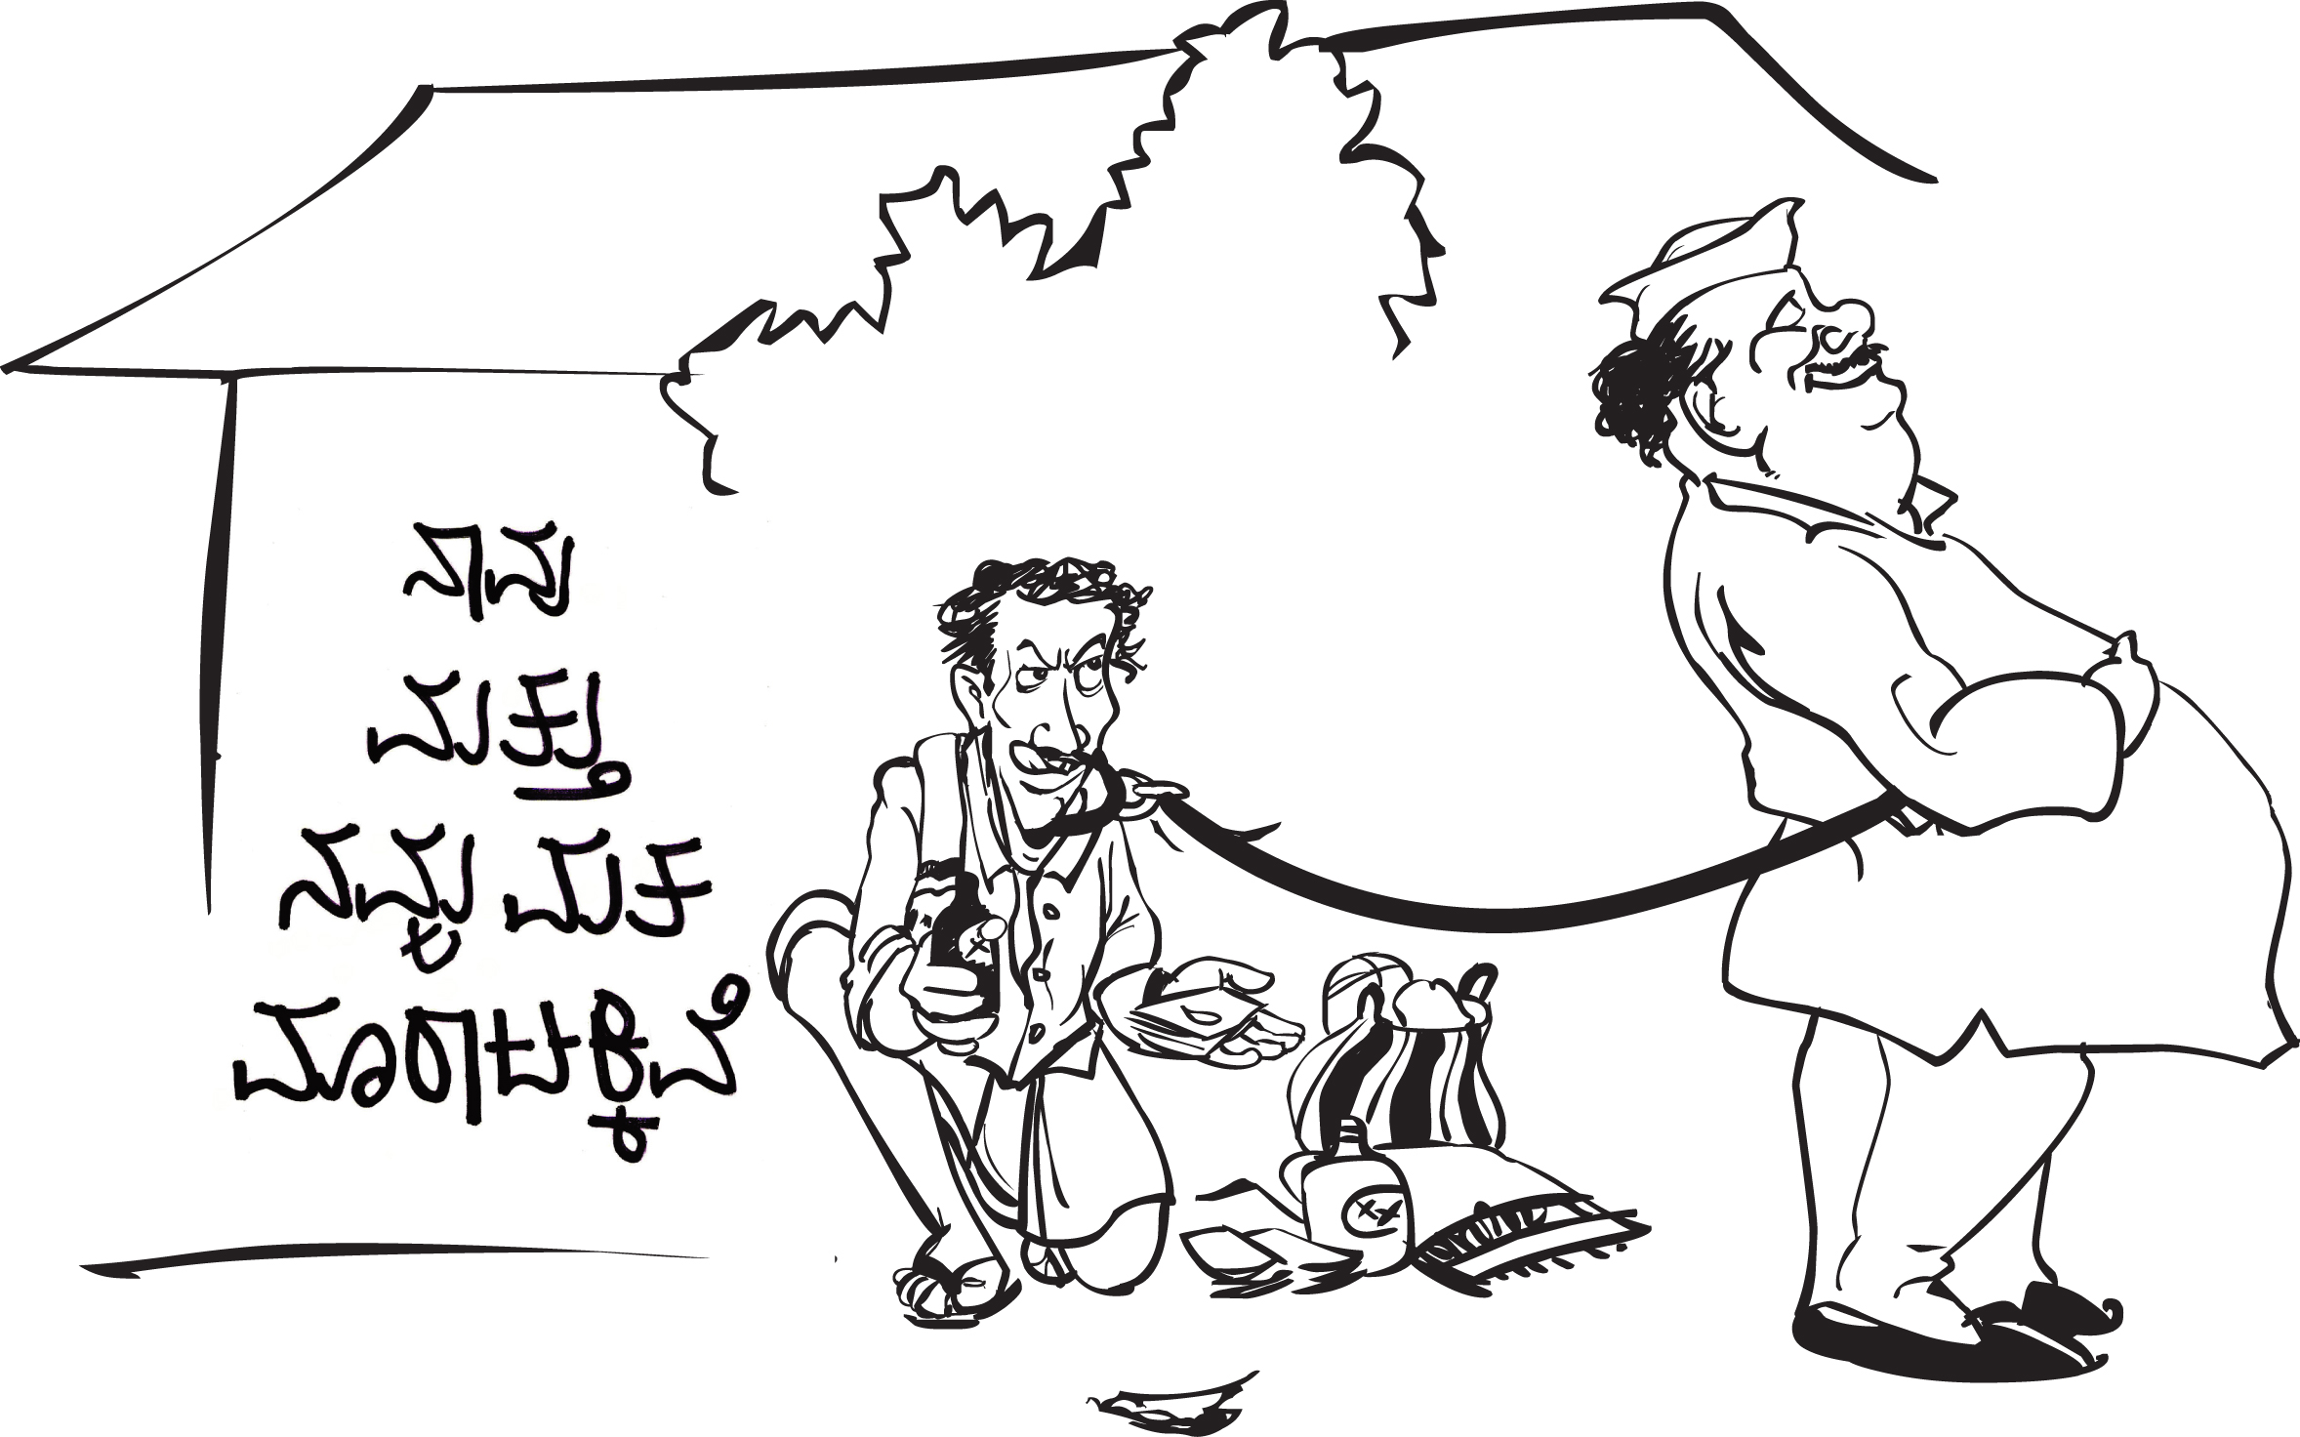
  - House to House: Go house to house with the two illustrated stickers designed for [1] Me and my vote is for sale and [2] Me and my vote is not for sale; and ask voters to choose which one they would like to stick near their door.
  - Discussion: Ensure that there is a discussion with the voters and that their concerns are taken on board. Remember, only a convinced voter will be able to resist money power.
  - Stickers for Payment: Remember to carry a hundi and collect Rs: 2/- for the illustrated sticker. Ensure that the sticker is displayed were the maximum people can see it; for example: to the right of the front door.
  - Individuals: Individuals such as Auto and Bus drivers should be approached on a one to one basis and offered the illustrated stickers or the smaller slogan sticker. Remember to collect Re: 1/- for the slogan stickers. Ensure that the sticker is displayed were the maximum people can see it; for example at the back of the vehicle.
  - Shops and Public Places: Ensure that the illustrated stickers are also displayed at shops and other public places.
  - A Day of Fasting: The Mattadara Swabhimana Horata: will be marked by a day of fasting in selected districts of Karnataka in order to invite citizens to introspect and consider their rights, power and obligations as citizens and the sanctity of their vote.

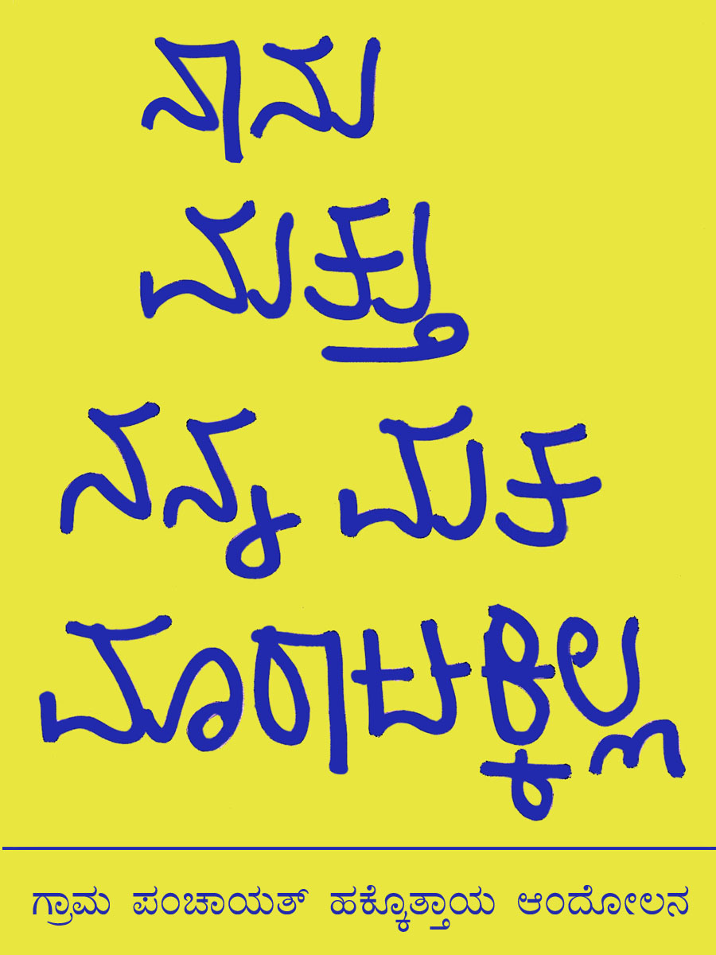
- Ensure a ‘Clean’ Election: To ensure that this election is ‘clean’ and money power is not unleashed in the constituencies to buy votes or induce the youth to campaign for candidates backed by political parties.
  - Three big baskets to be placed at the Gram Panchayat office where they are most visible to passers by. Label one ‘sarai’, the other ‘hanna’ and the third ‘seerai’.
  - Constitute teams to watch out for the entry of money, liquor or other allurements at all the entries to your village and ensure that the watch is 24x7 through a shift system and be especially vigilant at night.
  - Put the flexi posters at the entrance to your village and at the Panchayat Office to warn corrupt elements to stay away from your ward.

- Youth Power: The youth should be approached on a one to one basis and offered the illustrated stickers or the smaller slogan sticker. The rationale for this campaign should be discussed and the importance of their vote and their rights and power as citizens and members of the Gram Sabhas should be explained. The objective is to convince them and offer an honourable alternative that they can be proud to identify with. Please give them the slogan badge and remember to collect the payment for it.

Objective 3:
The Gram Panchayat Hakkottaya Andolana has filed a PIL before the High Court of Karnataka through our Advocate Sumana Baliga asking for:
- Striking down of the order of appointment of administrators;
- A clear direction from the court to directing the SEC to conduct elections as per a schedule for the remaining 150 Gram Panchayats, the coming Taluk and Zilla Elections; and
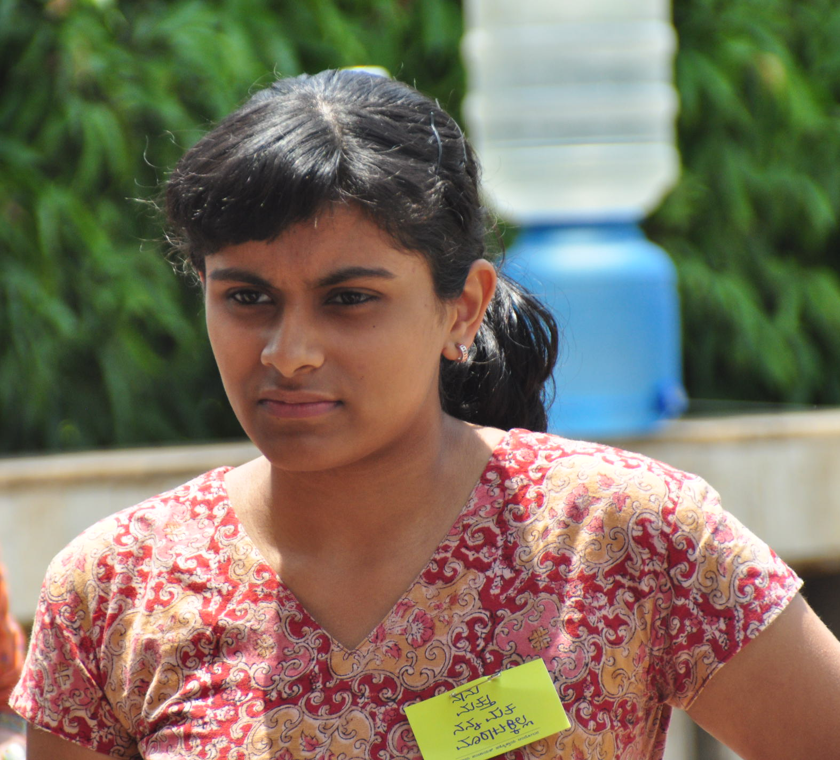
- Strictures to be passed upon the SEC for clearly not performing his constitutional duty of announcing the elections.

The strategy to fulfil objective three included:
- Letters to
- Resolutions passed at Ward Sabhas
- Articles and Press Notes to the Media
- Legal action and pressure on the SEC to resign.
- We also met with the Honourable Governor of Karnataka to request him to seek the SEC's written explanation as to why a constitutionally independent authority has abused his position and violated the Constitution and seek his impeachment.

COVERAGE:
This Andolan Campaign covered 10% of the Gram Panchayats in Karnataka that were notified for the I and II Phase of this election in 19 out of a otal of 29 districts.
Total Coverage
Districts covered – 19
Taluks covered – 53
Panchayats covered – 443
Andolan candidates – 841
SHGs covered in Udupi – 76
Houses covered in Udupi – 10,450

In some areas this was done by members of the Andolan with volunteers of the Andolan Secretariate and in others in partnership with Andolan member organisations such as Mahalya Samakya, the J. H. Patel Foundation and Hunger Project.

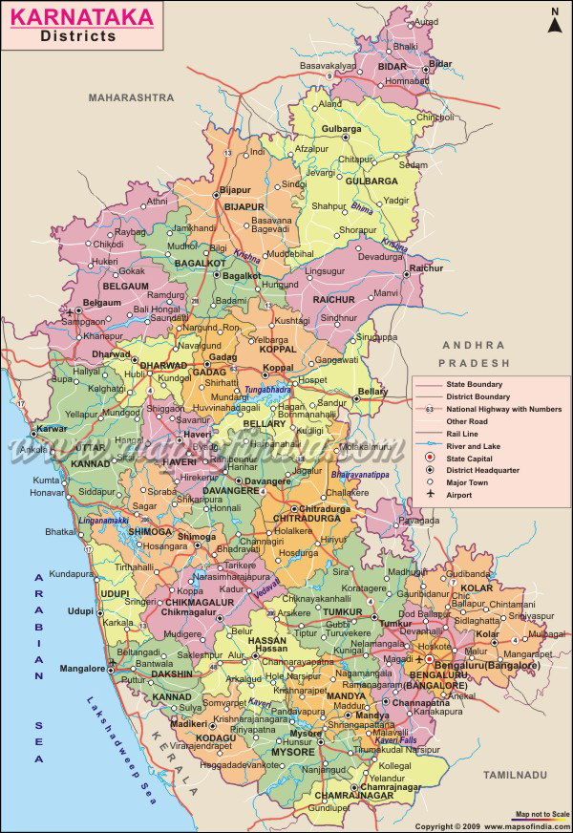
IMPACT:
Contrary to the general belief, the campaign was welcomed enthusiastically. We received a very heartening response that was exhilarating. People said ‘we needed a campaign such as this one’.

154 candidates won out of a total of 242 candidates supported by the Andolana in Kundapura Taluk alone. In the 19 districts covered 749 candidates out of 1513 won. There was an overwhelming response from women and youth and several candidates adopted the campaign, some candidates even requested our assistance in their campaign and many (non Andolana) candidates signed our oath.

There were instances where the BJP and Congress came together to field candidates against the Andolana and leaders of political parties who were scheduled to campaign, cancelled their programmes.

The use of money and muscle power was not visible and if it was used at all, it was surreptitiously. No handbills with the usual pictures of political leaders were used and political parties appeared to keep a low profile.

Many prominent writes, thinkers and artists supported the Andolana. In Bagalkot, a civil judge released our sticker. Freedom fighter lauded this as much needed initiative. The Andolan was able to expand its support through new members and partners.

The local media gave prominence to the Andolana and covered the process extensively and we were able to gain new insights into standard election practices from the testimonies of people.

Surprisingly we found that the very poor were against selling their votes and willingly bought stickers and put them on their walls with pride. It was the moderately rich who were often in a dilemma as to whether or not to support this campaign. This campaign provided a voice to the voiceless and generated extensive discussion and debate among voters. It provided the ‘honourable’ with an alternative that they could identify with. One person said “For those who are honest, there is a strong need for a forum such as ours – that is the reason in 40 days we were able to have such an impact”

Women seemed more able to resisted taking money for votes, while men were lured by money or liquor. Women’s groups rejected money even when it was placed before them

People felt that this campaign has been very effective in the Panchayat level and should be taken up at Taluk and Zilla Levels in a sustained manner.

Constraints:
“We had lost hope.
With this campaign you have brought us hope. We are with you”.

Basavalingiah of Davangeri

We did face some difficulties. For example in Uttara Kannada we had difficulty obtaining police permission and in Coorg our activists were threatened. Some members of the Andolana aligned with political parties and we received very poor response from candidates in Mysore and Chamrajnagar.

